# Chicken pasture-raised and organic products

When selecting pasture-raised and organic chicken, it's important to understand the distinctions between various labels to make informed choices. Here's a brief overview:

* **Organic Chicken**: Certified organic chickens are fed 100% organic, non-GMO feed and are not given growth hormones or antibiotics. They must have access to the outdoors, though this doesn't guarantee extensive pasture time.  
   [Fed By The Farm](https://fedbythefarm.com/pasture-raised-vs-organic-chicken/?utm_source=chatgpt.com)
* **Pasture-Raised Chicken**: These chickens spend significant time outdoors on pasture, foraging for natural foods like insects and grasses, which can enhance the nutritional profile of the meat. However, the term "pasture-raised" isn't regulated by the USDA, so standards can vary.  
   [Fed By The Farm](https://fedbythefarm.com/pasture-raised-vs-organic-chicken/?utm_source=chatgpt.com)

Here are some notable brands offering pasture-raised and organic chicken:

**Vital Farms**Known for its pasture-raised eggs, Vital Farms also offers pasture-raised chicken, emphasizing humane and sustainable farming practices.

[Investors](https://www.investors.com/news/vital-farms-pilgrims-pride-food-inflation-bird-flu/?utm_source=chatgpt.com)

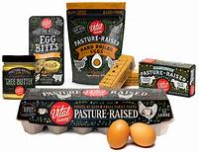

**Primal Pastures**A family-owned farm providing beyond organic, pasture-raised, corn- and soy-free chicken, delivering nationwide.

[Primal Pastures](https://primalpastures.com/?utm_source=chatgpt.com)

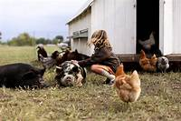

**Crowd Cow**Offers a variety of chicken products, including organic free-range options, sourced from sustainable farms.

[The Honest Consumer](https://www.thehonestconsumer.com/blog/organic-vs-pasture-raised-chicken?utm_source=chatgpt.com)

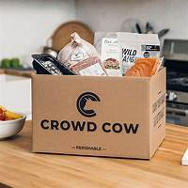

**ButcherBox**Provides subscription boxes featuring free-range organic chicken, along with other meats, focusing on quality and ethical sourcing.

[New York Magazine](https://nymag.com/strategist/article/best-meat-delivery.html?utm_campaign=feed-part&utm_medium=social_acct&utm_source=chatgpt.com)

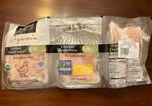

**Porter Road**Delivers pasture-raised, hormone- and antibiotic-free chicken, offering various cuts and subscription options.

[New York Magazine](https://nymag.com/strategist/article/best-meat-delivery.html?utm_campaign=feed-part&utm_medium=social_acct&utm_source=chatgpt.com)

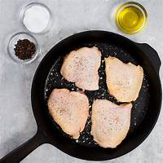

When choosing a brand, consider factors such as farming practices, animal welfare standards, and transparency about sourcing to ensure the chicken aligns with your health and ethical preferences.

When selecting pasture-raised and organic chicken, it's important to understand the distinctions between various labels to make informed choices. Here's a brief overview:

* **Organic Chicken**: Certified organic chickens are fed 100% organic, non-GMO feed and are not given growth hormones or antibiotics. They must have access to the outdoors, though this doesn't guarantee extensive pasture time.
* **Pasture-Raised Chicken**: These chickens spend significant time outdoors on pasture, foraging for natural foods like insects and grasses, which can enhance the nutritional profile of the meat. However, the term "pasture-raised" isn't regulated by the USDA, so standards can vary.

Here are some notable brands offering pasture-raised and organic chicken:

**Pasturebird**A leading producer of pasture-raised chicken, Pasturebird raises chickens outdoors on fresh pasture daily, emphasizing regenerative agriculture practices.

[Pasturebird](https://www.pasturebird.com/?utm_source=chatgpt.com)

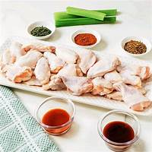

**Elmwood Stock Farm**This family-owned farm offers USDA-certified organic, pasture-raised chicken, focusing on humane treatment and sustainable farming methods.

[Elmwood Stock Farm](https://elmwoodstockfarm.com/products/organic-poultry/?utm_source=chatgpt.com)

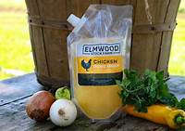

**Greener Pastures Chicken**Specializing in regenerative organic farming, they provide pasture-raised, stress-free chickens without antibiotics, hormones, or GMOs.

[Greener Pastures Chicken](https://greenerpastureschicken.com/?utm_source=chatgpt.com)

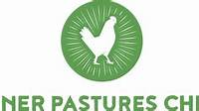

**Grass Roots Farmers' Cooperative**A cooperative offering pasture-raised, non-GMO, antibiotic-free chicken, with a focus on transparency and sustainability.

[Grassroots Coop](https://grassrootscoop.com/collections/pastured-chicken?utm_source=chatgpt.com)

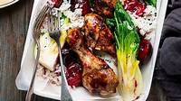

**Tussock Sedge Farm**Provides 100% pasture-raised heritage breed chickens that are corn-free, soy-free, and chemical-free, raised slowly for optimal flavor and nutrition.

[Tussocks Edge Farm](https://tussocksedgefarm.com/store/pastured-chicken?utm_source=chatgpt.com)

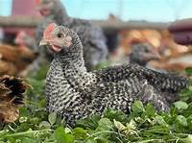

**The Family Cow**Offers truly pasture-raised, soy-free, corn-free, and chemical-free chickens, moved to fresh organic grass daily to ensure a natural diet and environment.

[Your Family Farmer](https://yourfamilyfarmer.com/store/pastured-poultry?utm_source=chatgpt.com)

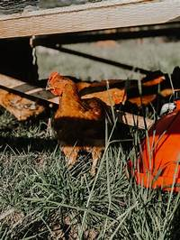

When choosing a brand, consider factors such as farming practices, animal welfare standards, and transparency about sourcing to ensure the chicken aligns with your health and ethical preferences.

Whole Foods Market offers a variety of pasture-raised and organic chicken options, including their own 365 by Whole Foods Market brand and products from reputable suppliers. Here are some notable options:

**365 by Whole Foods Market Organic Boneless Skinless Chicken Breasts**These USDA-certified organic chicken breasts are free from antibiotics and added hormones, providing a versatile option for various recipes.

[Whole Foods Market](https://www.wholefoodsmarket.com/products/meat/chicken?utm_source=chatgpt.com)

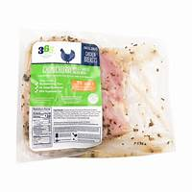

**Mary's Free Range Organic Boneless Skinless Chicken Breasts**Mary's Free Range offers organic, air-chilled chicken breasts from humanely raised chickens, ensuring high quality and flavor.

[Whole Foods Market](https://www.wholefoodsmarket.com/products/meat/chicken?utm_source=chatgpt.com)

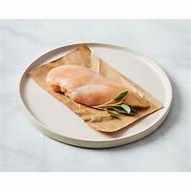

**Whole Foods Market Pasture Raised Whole Chicken, Step 4**This whole chicken meets Global Animal Partnership's Step 4 standards, indicating enhanced outdoor access and pasture-centered farming practices.

[Whole Foods Market](https://www.wholefoodsmarket.com/product/pasture-raised%20whole%20chicken%2C%20step%204-b0bd5t58fz?utm_source=chatgpt.com)

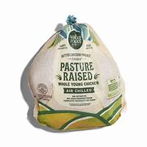

**Mary's Free Range Organic Whole Chicken**Mary's Free Range provides whole chickens that are USDA-certified organic, free from antibiotics, and raised humanely, ensuring a wholesome choice for meals.

[Whole Foods Market](https://www.wholefoodsmarket.com/products/meat/chicken?utm_source=chatgpt.com)

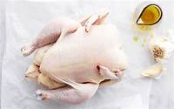

**365 by Whole Foods Market Organic Ground Chicken**This organic ground chicken is versatile for various recipes and is free from antibiotics and added hormones, aligning with Whole Foods Market's quality standards.

[Whole Foods Market](https://www.wholefoodsmarket.com/products/meat/chicken?utm_source=chatgpt.com)

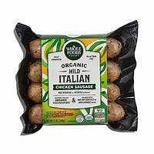

Outpost Natural Foods, a cooperative with multiple locations in Wisconsin, is dedicated to offering a diverse selection of natural and organic products, including pasture-raised and organic chicken. While their inventory can vary, here are some notable brands and local farms whose products are available at Outpost:

**Kellner Back Acre Garden**Based in Denmark, Wisconsin, this farm supplies Outpost with organic poultry products, including chicken and duck eggs. Their commitment to organic farming practices ensures high-quality offerings.

[Shepherd Express](https://shepherdexpress.com/food/eat-drink/outpost-natural-foods-boosts-community-local-businesses-and-/?utm_source=chatgpt.com)

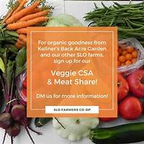

**Organic Valley**Headquartered in La Farge, Wisconsin, Organic Valley is a cooperative of organic farmers providing a range of organic products, including dairy and meat. Their organic chicken is raised without antibiotics and with access to outdoor pasture.

[Wikipedia](https://en.wikipedia.org/wiki/Organic_Valley?utm_source=chatgpt.com)

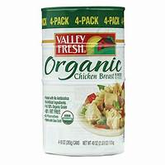

**Alden Hills Organic Farms**Located in Walworth, Wisconsin, Alden Hills offers grass-fed, organic meats, including chicken. Their focus on sustainable and humane farming practices aligns with Outpost's commitment to quality.

[Milwaukee Magazine](https://www.milwaukeemag.com/8-certified-organic-wisconsin-farms-to-check-out/?utm_source=chatgpt.com)

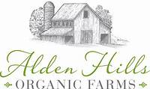

**Gwenyn Hill Farm**Situated in Waukesha, Wisconsin, Gwenyn Hill provides certified organic produce and pasture-raised meats. Their dedication to regenerative agriculture contributes to the sustainability of local food systems.

[Milwaukee Magazine](https://www.milwaukeemag.com/8-certified-organic-wisconsin-farms-to-check-out/?utm_source=chatgpt.com)

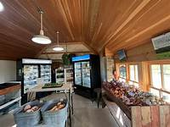

**Turtle Creek Gardens**Based in Delavan, Wisconsin, this farm offers organic vegetables and pasture-raised meats, including chicken. Their commitment to organic farming supports the health of the community and the environment.

[Milwaukee Magazine](https://www.milwaukeemag.com/8-certified-organic-wisconsin-farms-to-check-out/?utm_source=chatgpt.com)